STRESSES IN AXIALLY LOADED BARS
Consider a bar of cross-sectional area $A$subjected to a force P along the axis of the bar.
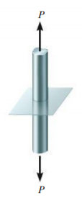 | 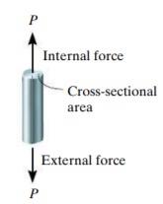 | 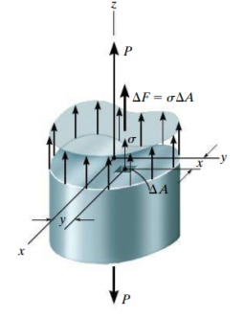 | If we consider the free-body diagram of one part of the body, for equilibrium, the internal forces should produce a resultant force P as shown. Look at the forces distributed over the cross-section. Consider a small elemental area $∆A$ on the cross-section at a distance $(x,y)$ from the co-ordinate axes.
Let $∆F$ be the internal force acting over this area. Then, we know by the definition of the stress,
$σ=\frac{∆F}{∆A} ≫≫ ∆F=σ ∆A$.
If we take infinitesimally small area, the above equation can be written as $dF=σ dA$. For equilibrium, $ΣF_{z}=0$
The sum of all such infinitesimal internal forces should be equal to $P.$
$$P-\int{dF=0≫≫ P=\int{σ dA}}$$
If the stress is uniform throughout the cross section (i.e., $σ$is the same where ever we consider the elemental area on the cross section)
$$P=σ\int{ dA}= σ. A ≫≫≫ σ=\frac{P}{A}$$
$$ΣM_{x}=0 ≫≫≫≫ \int{dF. y}=0 ≫≫ \int{σ dA y=0 ≫≫ σ\int{y dA=0 ≫ \int{y dA=0}}}$$
We know that $\int{y dA=\overline{y }A}.$Therefore, from above it is obvious that $\overline{y }=0$. That is, the x-axis should pass through the centroid of the cross section. Similarly,
$$ΣM_{y}=0 ≫≫≫≫ \int{dF. x}=0 ≫≫ \int{σ dA x=0 ≫≫ σ\int{x dA=0 ≫ \int{x dA=0}}}$$
That is, the y-axis passes through the centroid ($\overline{x }=0)$.
Hence the resultant of the internal forces passes through the centroid of the cross section if the stress distribution in axially loaded bars is to be uniform.

It is now clear that only normal stress exists on any small volume element located on every point on the cross section of an axially loaded bar. This is a uni-axial state of stress | 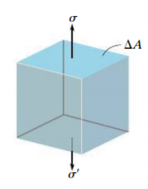 | 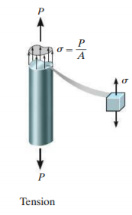 | 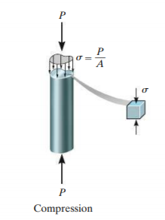

Axial strain (normal strain): If a rod length $L$has an elongation(compression) of $δ$ due to an axial tensile (compressive) force $F$, then the axial strain $ε_{xx}=\frac{δ}{L}$

Saint-Venant’s Principle
In the discussion of stress on axially loaded bars above, we have considered that the stress is uniform over the cross section. But, this assumption is not true near the load or the support. The localized effects of loading and supports vanishes as we move away from them. According to Saint-Venant’s principle, the stress distribution becomes uniform away from load or support at least a distance equal to the largest dimension of the cross section
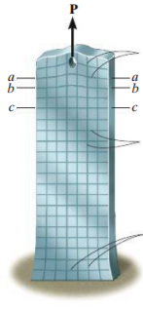  Lines distorted near the load  Lines not distorted away from ends  Lines distorted near the support |  | 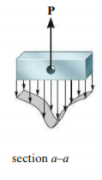 | 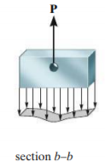 | 